# **Creating IBM MQ Instance**

1. Access the Platform Navigator. Login to the RedHat OpenShit Container Platform Console using the url, userid and password.

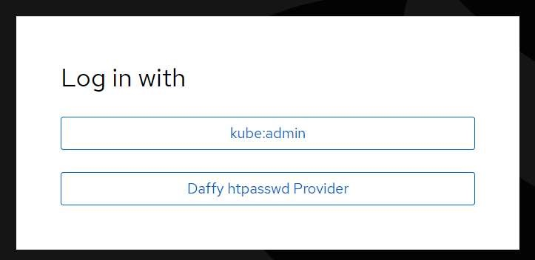

1. Expand **Network** and click **Routes** and change the project to **CP4I**.

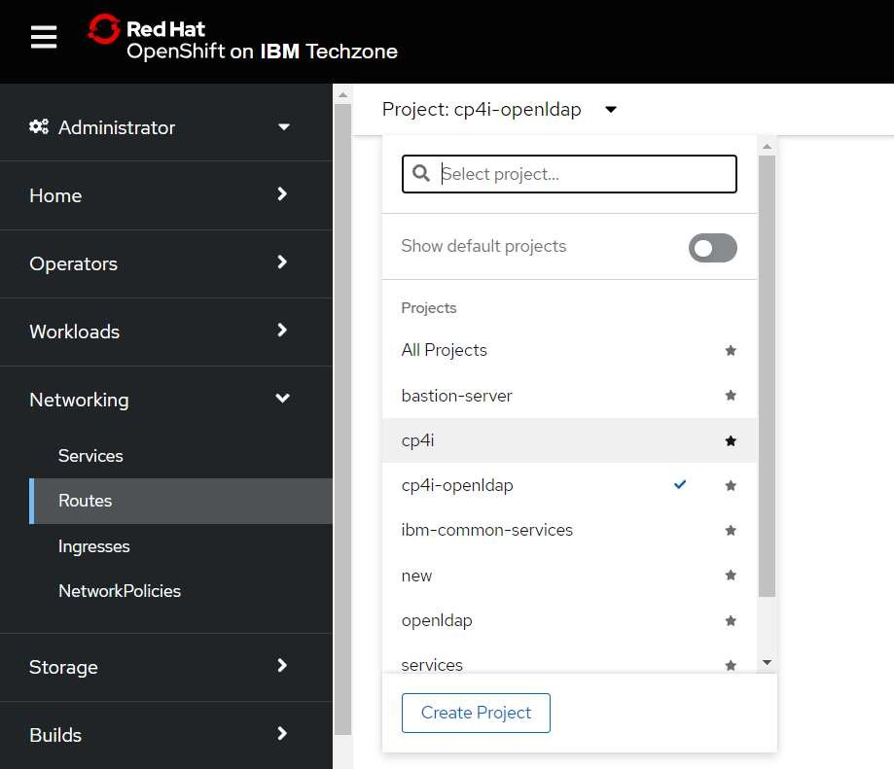

1. Search for **Platorm-navigator-pn** or the name of the platform navigator you have provided and click on the **url** under **location tab** to open cp4i Platform UI.

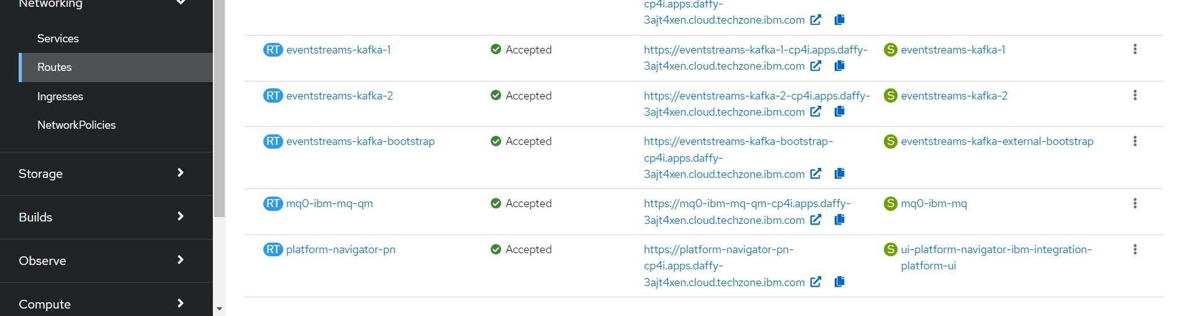

1. On clicking, cloud pak for integration Platform Navigator login screen is seen.

**Log in with = IBM Provided credentials**

**Username = admin**

**Password = < Need to accessed from secrets>**

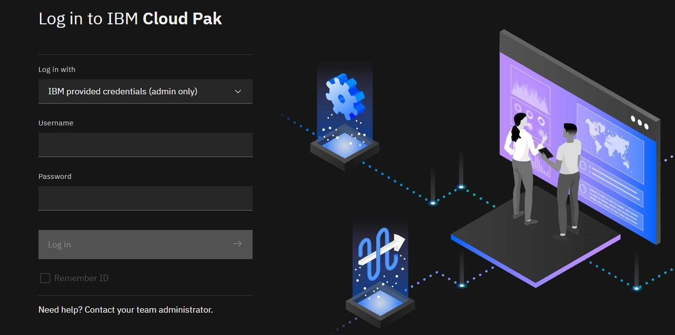

**Access the password for platform navigator**

1. In OpenShift Web Console go to Expand **Workload** and click **Secrets** and change the project to **ibm-common-services**.

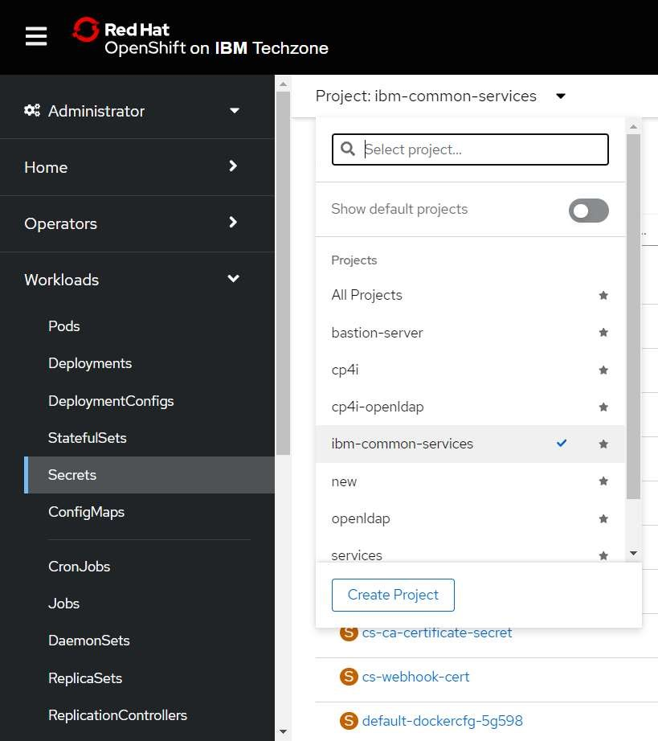

1. Search for the following secrets **platform-auth-idp-credentials** and click to open the same.

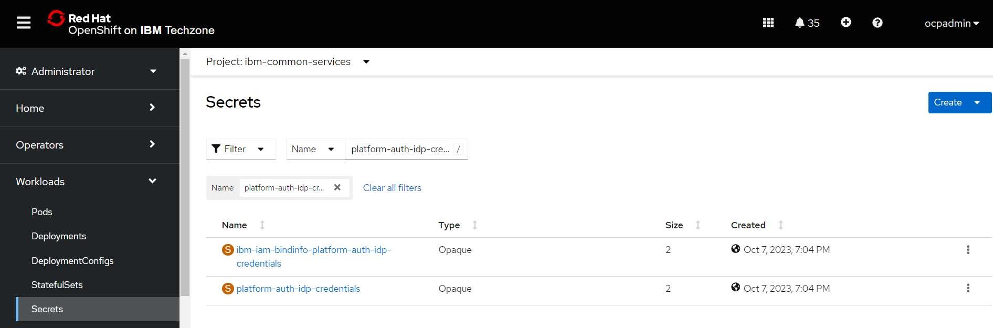

4. Goto the bottom of the screen and click on reveal values to reveal the username and password for the CP4I platform UI.

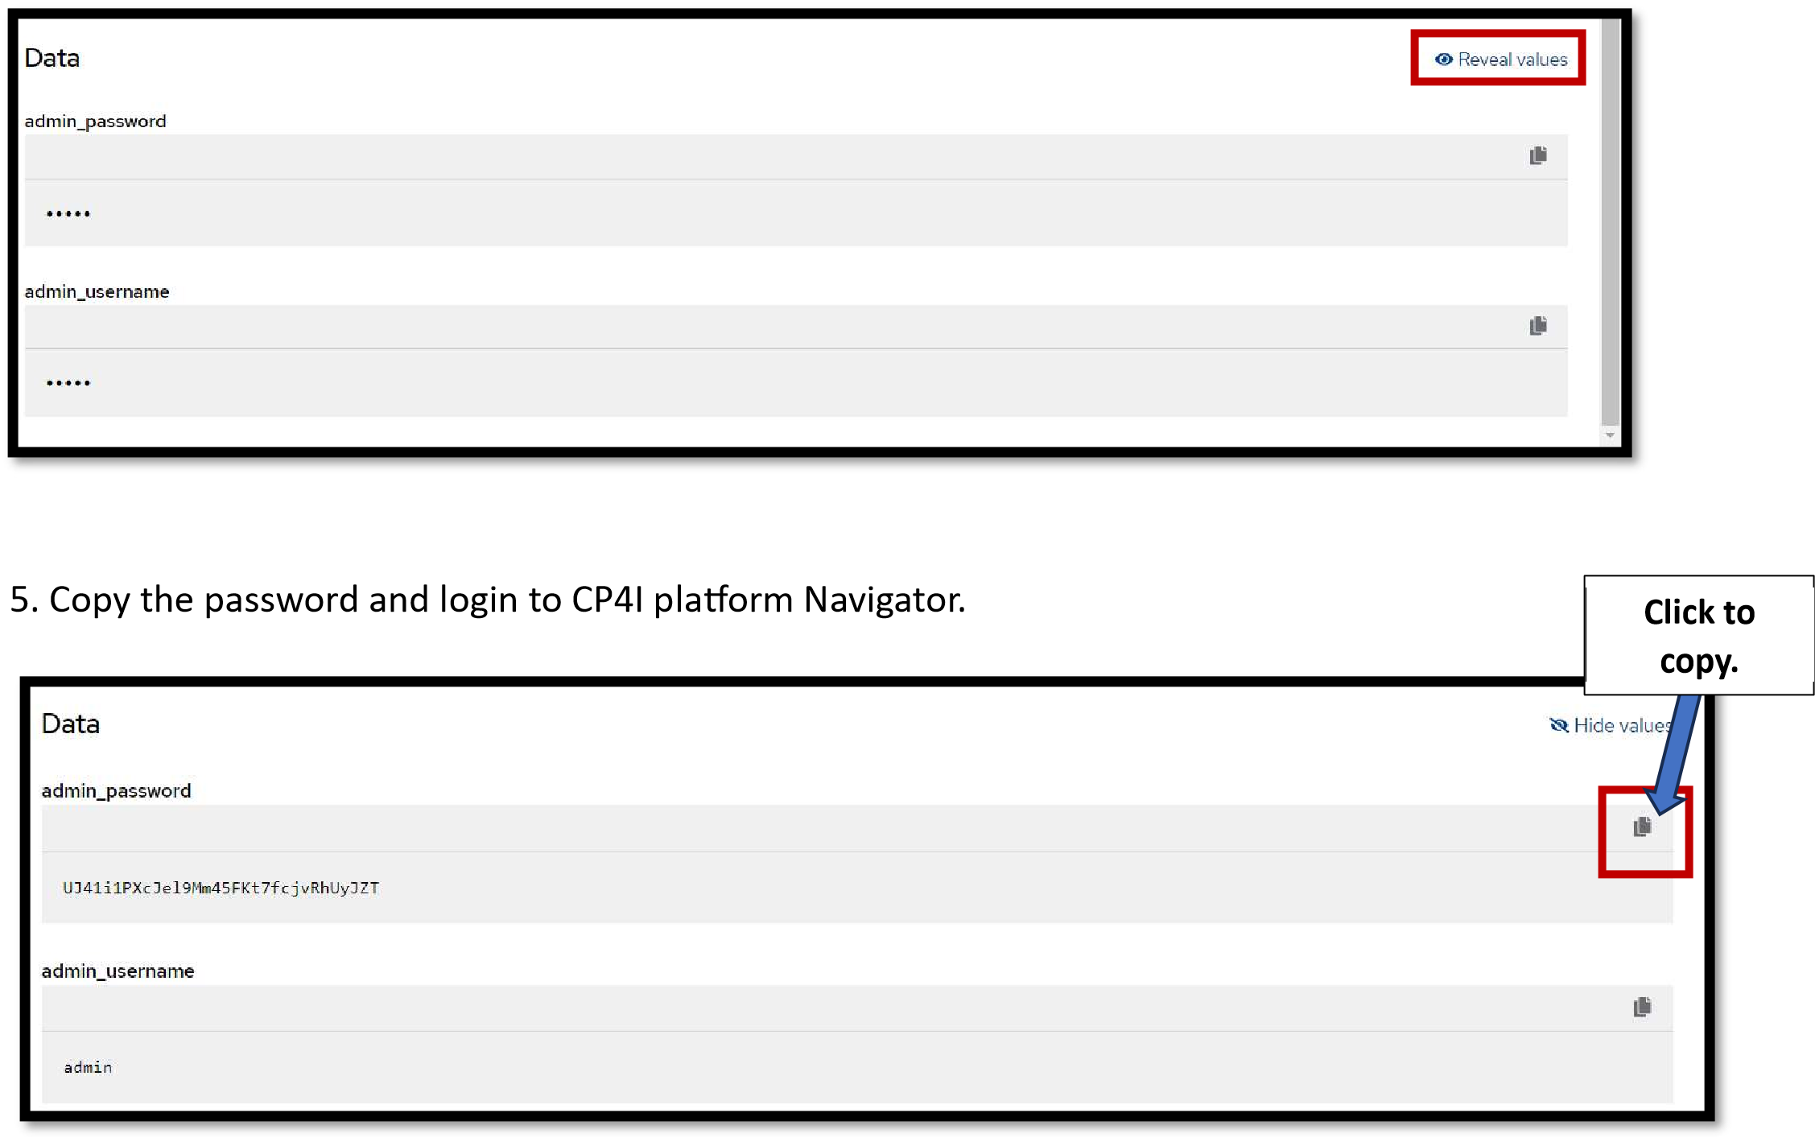

**Platform Navigator**

6. Login to the platform Navigator

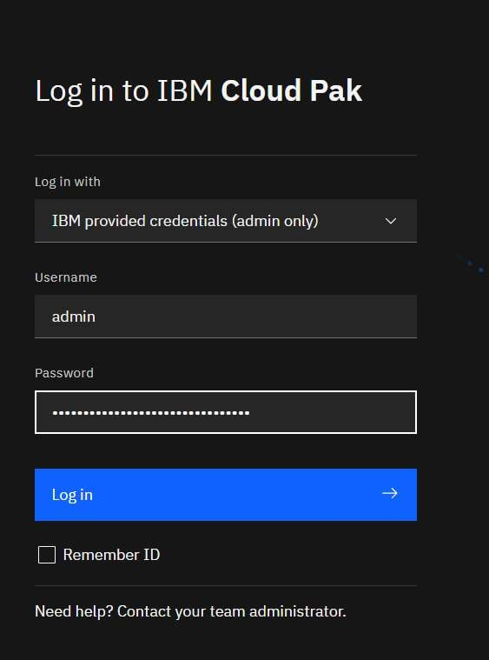

1. Click the **integration instances** tile or click on the menu and click **Administratio**n on and click on **Integration Instances**.

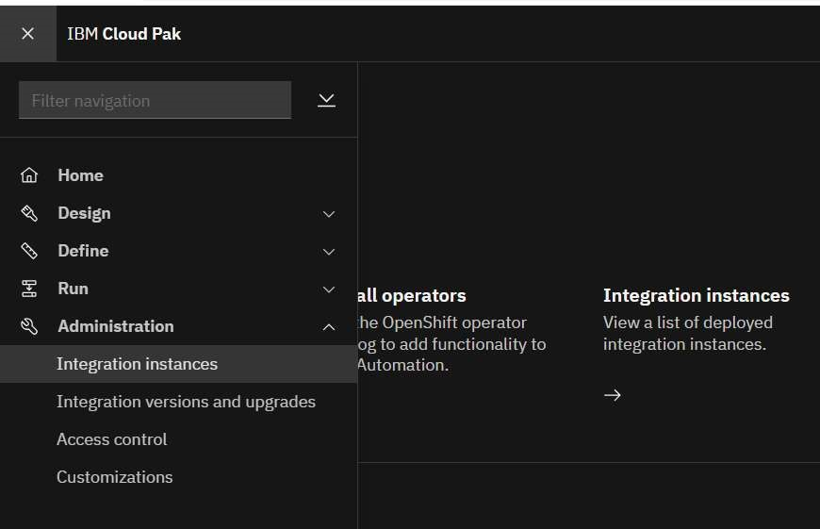

1. To create an instance of IBM MQ click **Create Instance** in the window

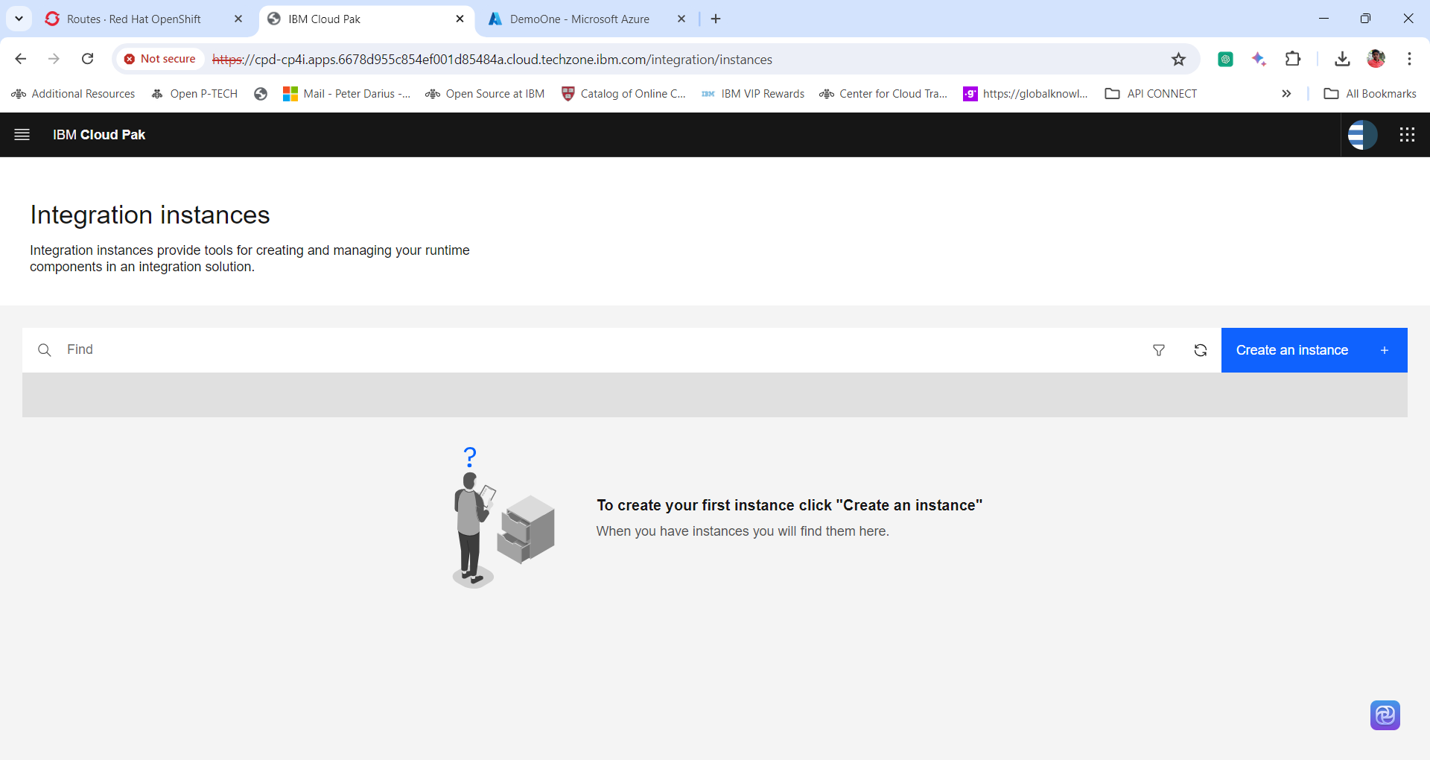

1. Select the Message tile and click Next. The message le will be enabled if the IBM MQ operator has successfully installed.

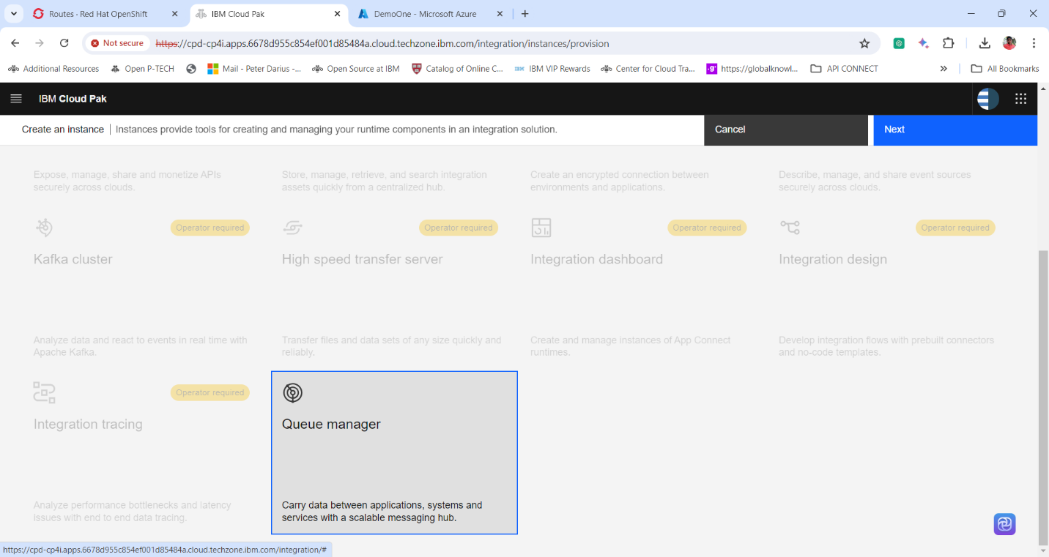

1. Next window displays the Sample les through which we can create the IBM MQ instances. Select the quick start le and click next.

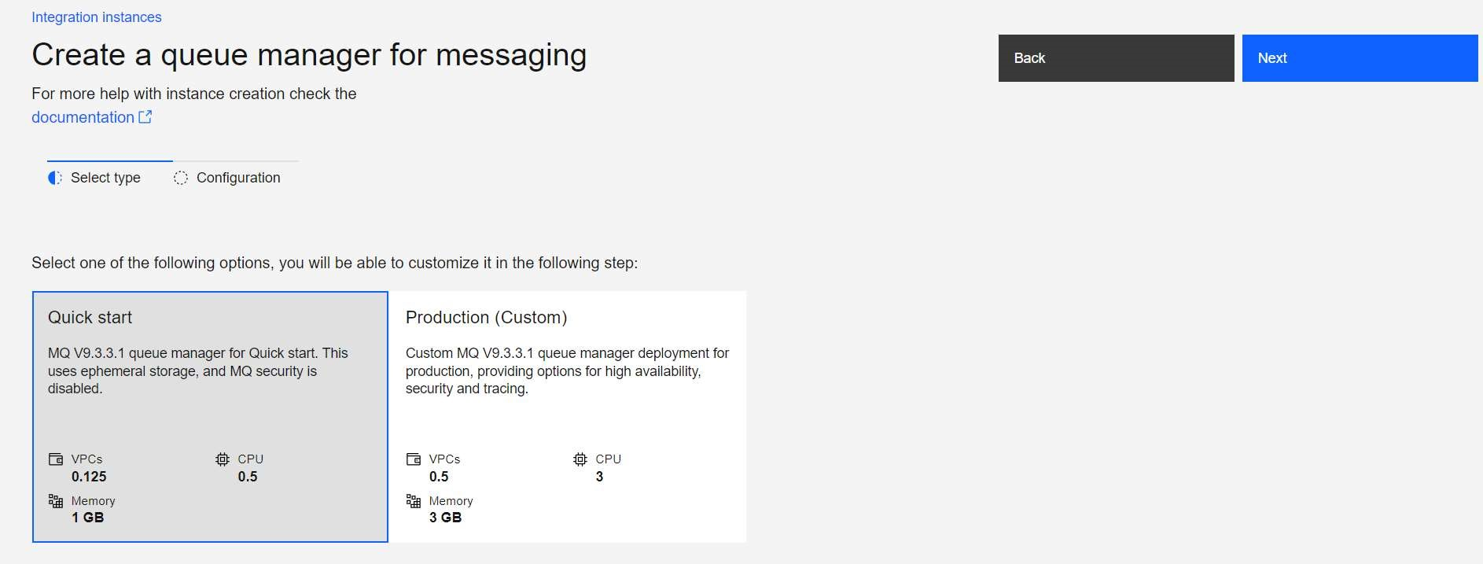

1. Provide the following configuration and create the IBM MQ instance.

**Name : quickstart-cp4i**

**Namespace: cp4i**

**License : Accept the License**

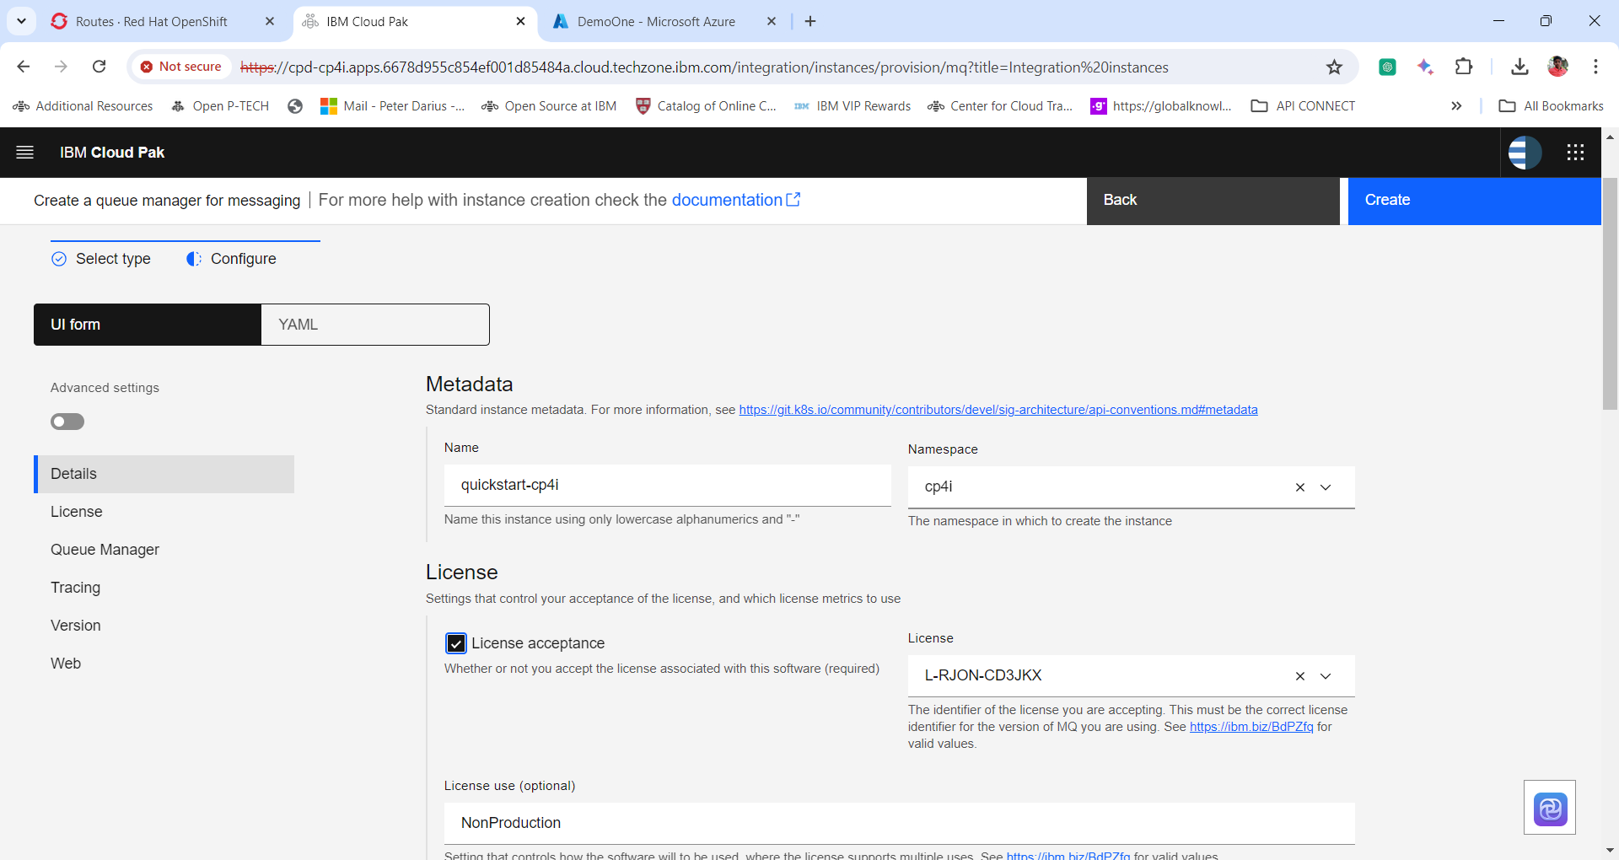

**NOTE:** If you would like to change the Queue Manager Name then enable Advance Settings and click Queue Manager and change the Queue Manager Name. ***(For this exercise lets keep the default Queue Manager)***

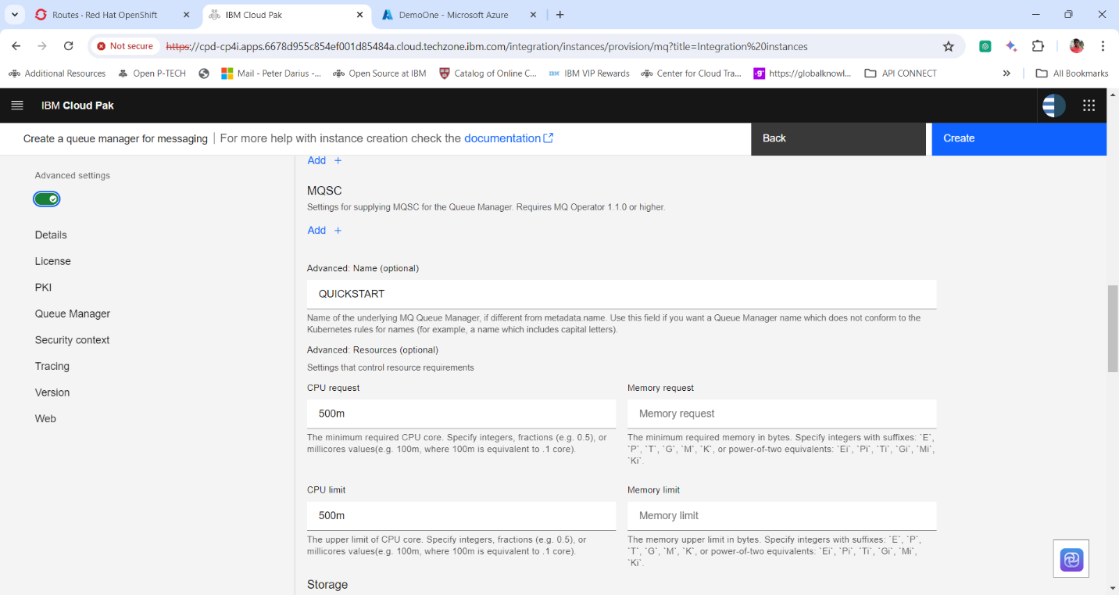

1. Click Create and wait for a few minutes to spin up the IBM MQ Instance.

1. Once the Instance is ready click on the **instance Name** to open up the IBM MQ Web Console.

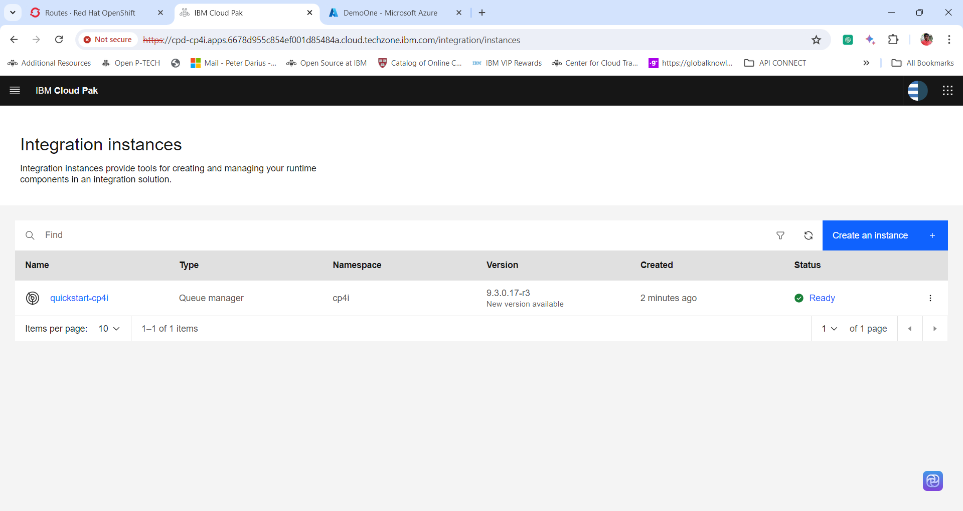

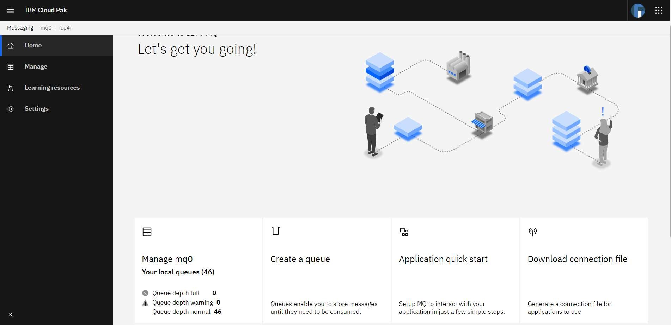

**Checking on the IBM MQ pods**

1. Open up the Red Hat OpenShift Console. And change the Project to **cp4i**.

2. Expand Workloads and click on pods.

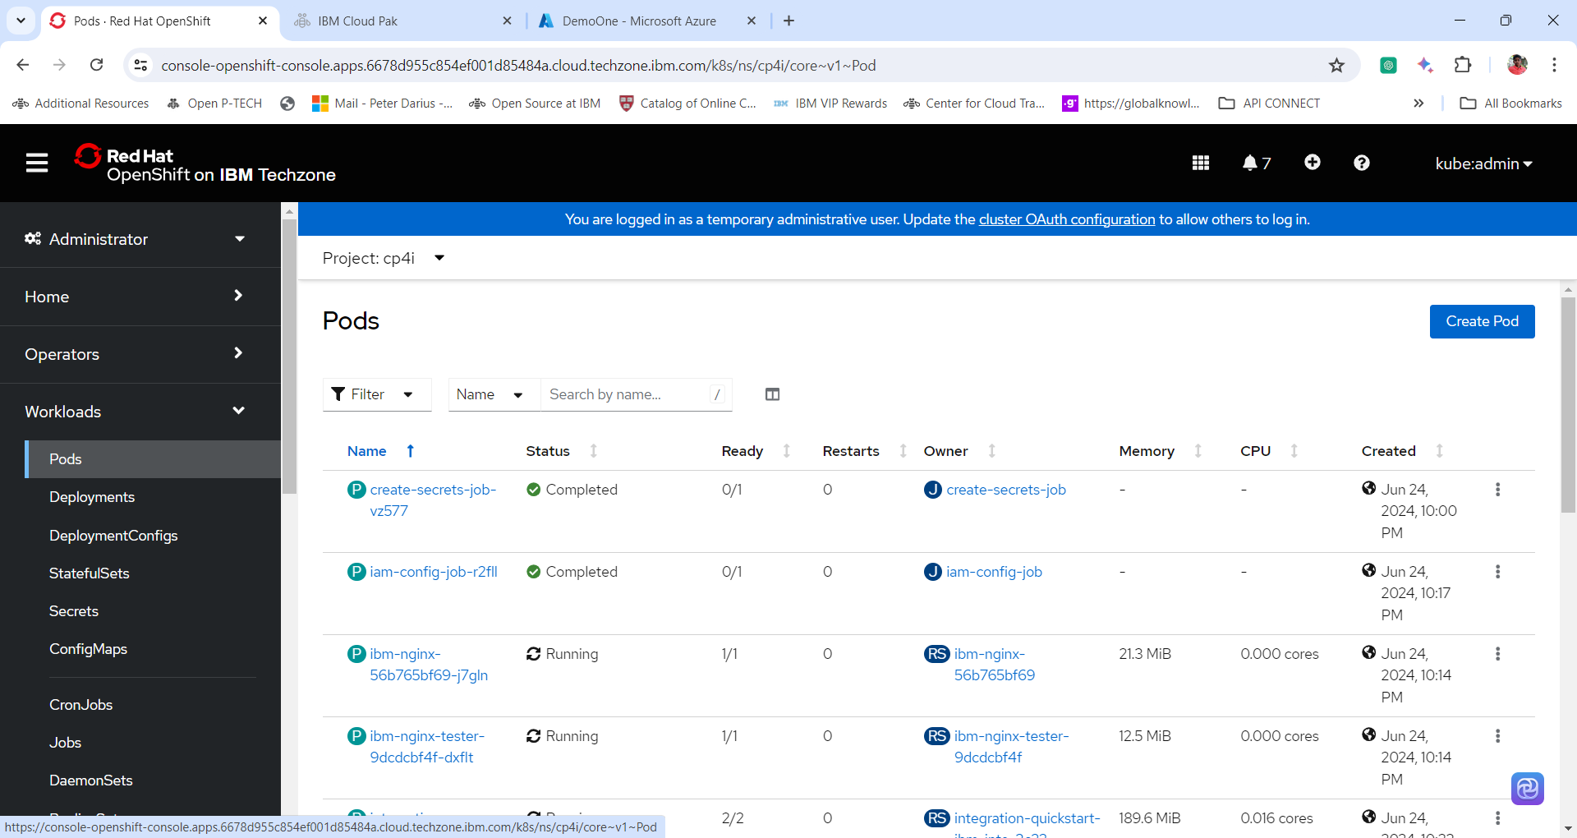

3. Search for the pod name quickstart-cp4i-ibm-mq. The naming convention for the IBM MQ pod is **<instance_name>-ibm-mq-<Some Random number>**

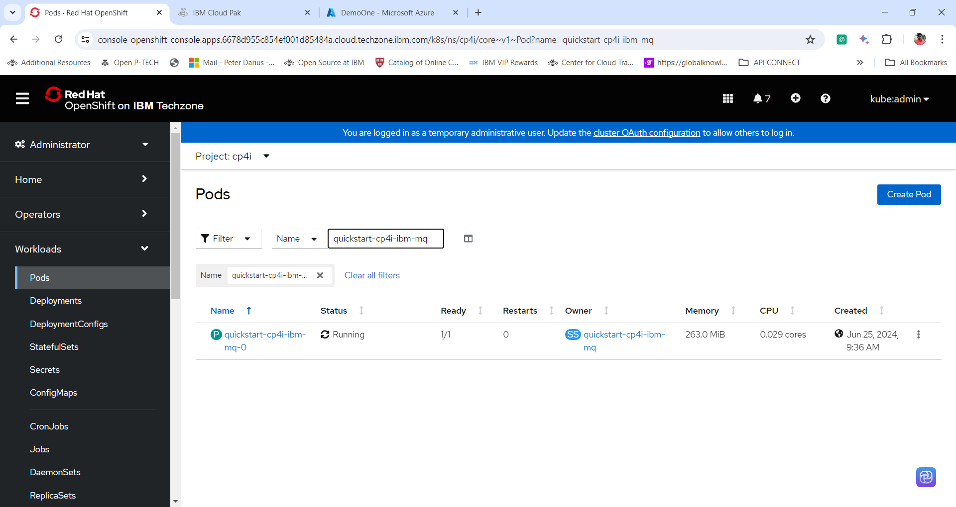

Thanks for successfully completing the IBM MQ installation Lab